Lecture 11 – Sensory neural prosthesis and transcutaneous energy

FIRST COCHLEAR IMPLANT (1978)

* Electrode array goes into cochlear
* Made from copper coil = inductor
  + Encapsulated in epoxy (may not have been medical grade)
  + Altogether went into electrode array
* Understanding risks:
  + By today’s standards, device would not be commercially marketed/implanted
  + Back in 1978, had a huge demand advocated for use
  + 2/3 prototypes failed, but since one worked Cochlear still gained approx. 65% of world market
    - Implanted in > 350,000 people
* 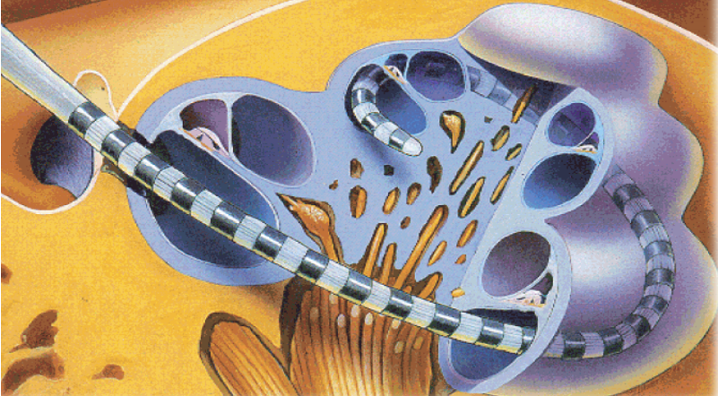Reference to picture (right)
  + Cochlear = bony material
    - Size of tip of pinky
  + Need some material that fits in, loops around and draws out electrical stimulation from electrodes
  + Target tissue = yellow = spiral ganglion cells
    - Collect and form auditory nerve
    - Goes to sound centers of brain to be interpreted
  + Action potential
    - 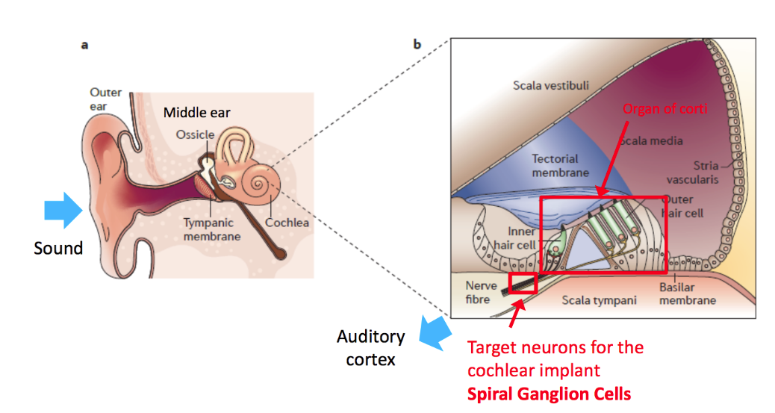Needed to transport signals

ORIGINS OF NEUROMODULATION

* Manipulate cells’ behavior by changing the extracellular potential
* Eg. Applying a voltage relative to the inside of a cell = membrane becomes charged
  + Action potential enables certain functions in body to occur

SENSORINEURAL HEARING LOSS

* Sound hits the tympanic membrane vibration
  + Ossicle augments vibration creates greater mechanical movement on middle ear
  + 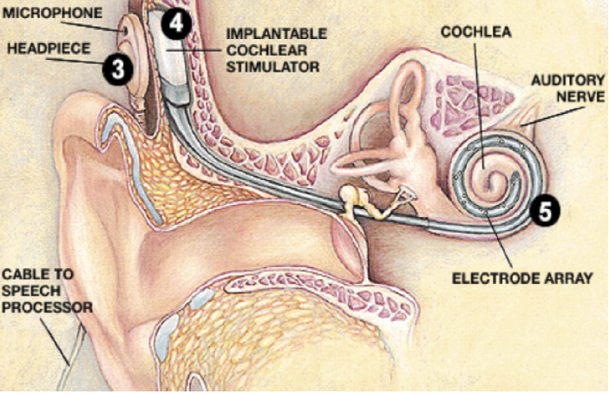Middle ear pushes onto cochlea, moving fluid around fluid movement bends into inner hair cells bending generates action potential ∴ sending signals to the brain
  + OCCURS IN THE ORGAN OF CORTI
* Target neurons for implant = spiral ganglion cells
  + Attached to hair cells
  + In diseases (eg. Meningitis) where hair cells are killed it cannot cause action potential from hair bending
* IF auditory nerve is present and functional, it can be electrically stimulated can detect sound
* Cochlear implant system
  + Outside = microphone + headpiece
  + 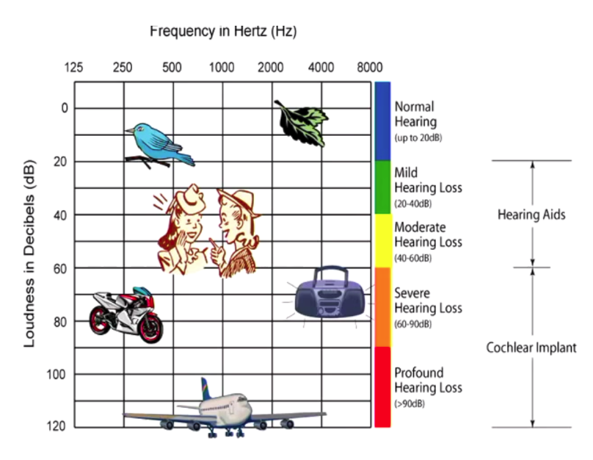Implantable cochlear stimulator cable through round window, into cochlear electrically stimulate various positions of cochlear

THE BIONIC EAR

* Stats:
  + Approx. 120 million are hearing impaired (Approx 1 million in Aus.)
  + 2% are fully deaf (2.4M worldwide, approx. 20K in Aus.)
  + FDA, initially let Cochlear implant into those profound deaf, as they thought it did more damage than good

THE STIMULUS WAVEFORM

* Use constant current pulses
  + 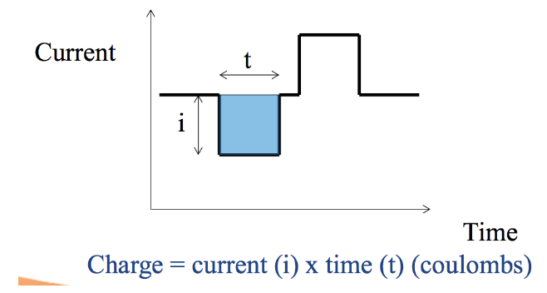 Other devices typically use voltage
* Phase 1 does all the work
  + Gets action potential firing by injecting charge (coulombs)
* Inter-phase gap
  + 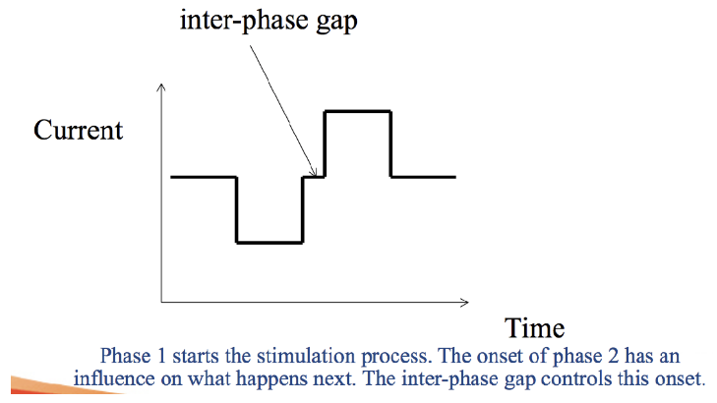Can be adjusted to what is most effective
  + Needed to allow time for action potentials to propagate down to designated area
* Phase 2
  + 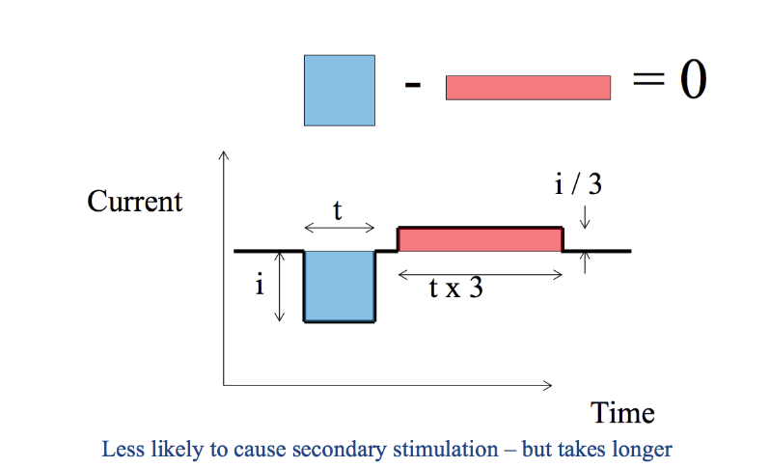Charge recovery = reverse the induced charge and restore neutrality ear is stimulated again without difficulties arising in electrochemistry
  + Without it, cause buildup of random chemicals and unwanted substances
  + Ideally, has the same amount of charge in second phase
    - But, in reality, not exactly equal due to ions/particles moving away from electrode site
  + Can still cause electrical stimulations
    - Solution: reduce current amplitude but have a pulse occur over a longer amount of time (area = 0)
* Charge = area under curve (sum must = 0, to be neutral)
* Inter-stimulus gap
  + Separation between pulses
  + Limited to how quickly you can feed information, and how quickly the electrodes are serviced
* Stimulation can only occur once at a time
  + Eg. If you have 22 electrodes, only one can be stimulated at a time

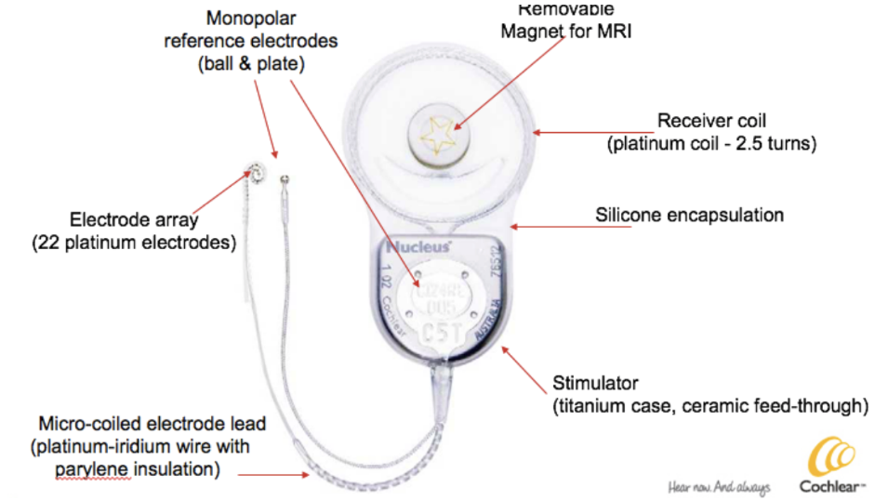NUCLEUS CI24RE

* 24 channels = 22 channels on electrode array + little monopolar reference electrode (ball + plate)
* Monopolar ref. electrodes = return path for the negative return of electrical stimulation
* Contact materials = silicone, titanium and platinum
* All electronics are placed in a little capsule = hermitic chamber
  + Connects to each of little wires
* 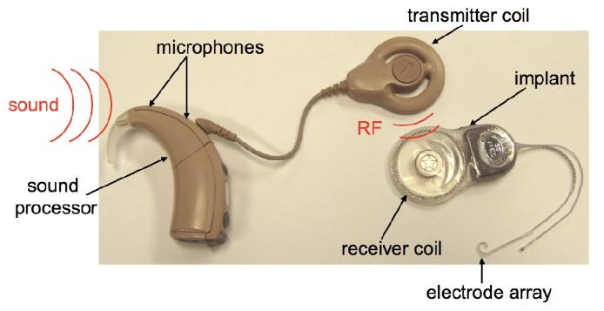Sound processor has 2x microphones
  + Picks up surround sound
  + Assumes most important sound is in front, so sound received = front minus behind sound
  + Sound processor sends instruction and power to the RF link
* RF link
  + 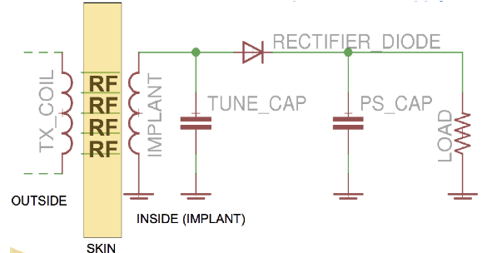Via inductive coupling
  + Outside TX (transmitting) coil RF signals go through skin implant (circuitry grabs energy off) detects when energy is turned on/off
  + Use RF coil to prevent infection from implanting
  + Don’t implant battery (due to big size); coils are very small allowing babies to wear them

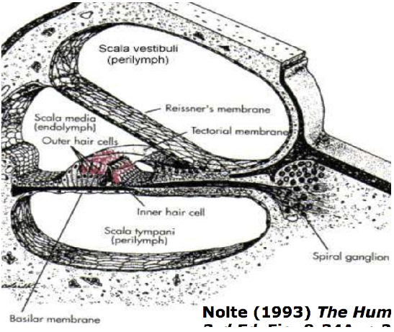ANATOMY OF COCHLEA

* Scala media (media = middle)
* Scala vestibula
* Scala tympani
  + Tympani membrane is where hair cells are excited
  + Target area = spiral ganglion cells
* In picture [right]; electrode array (grey) = metal
  + If e-pulses are emitted from metal, we can excite spiral ganglion cells and send signals off to the brain to be interpreted as sound
* Electrode array
  + 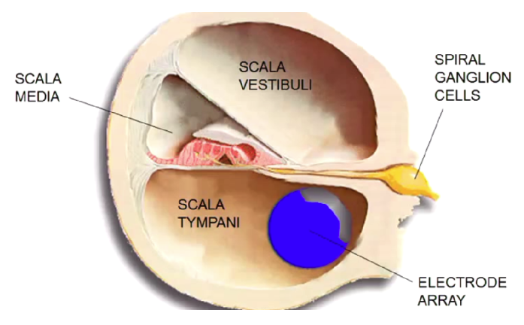Used to be straight, but presently curled
  + Cochlea is curled
  + Allows electrode to get close as possible to spiral ganglion cells
  + Electrical stimuli is directed inside curl of electrode; when it was straight, it will go outside
* BUT: looking at x-ray image, there is still so much of cochlea that isn’t reached
  + Consequences:
    - 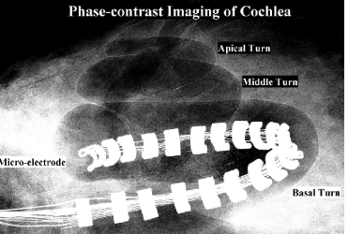Only detecting high pitch/frequency (low frequency = long wavelength penetrating through the deeper end of the cochlea
  + Goal:
    - Have widely spaced electrodes throughout the cochlea
    - Hear all sounds of the spectrum
  + Electrodes are limited to a range of frequencies; not a 1:1 correspondence (eg. Piano keys slammed hard)
  + In 25 years, < 7% of devices have failed